**Perks - Classes - List View**

The purpose of the page is for the supplier or admin to load a class that a user can view and book and view existing classes.

**Screenshot**

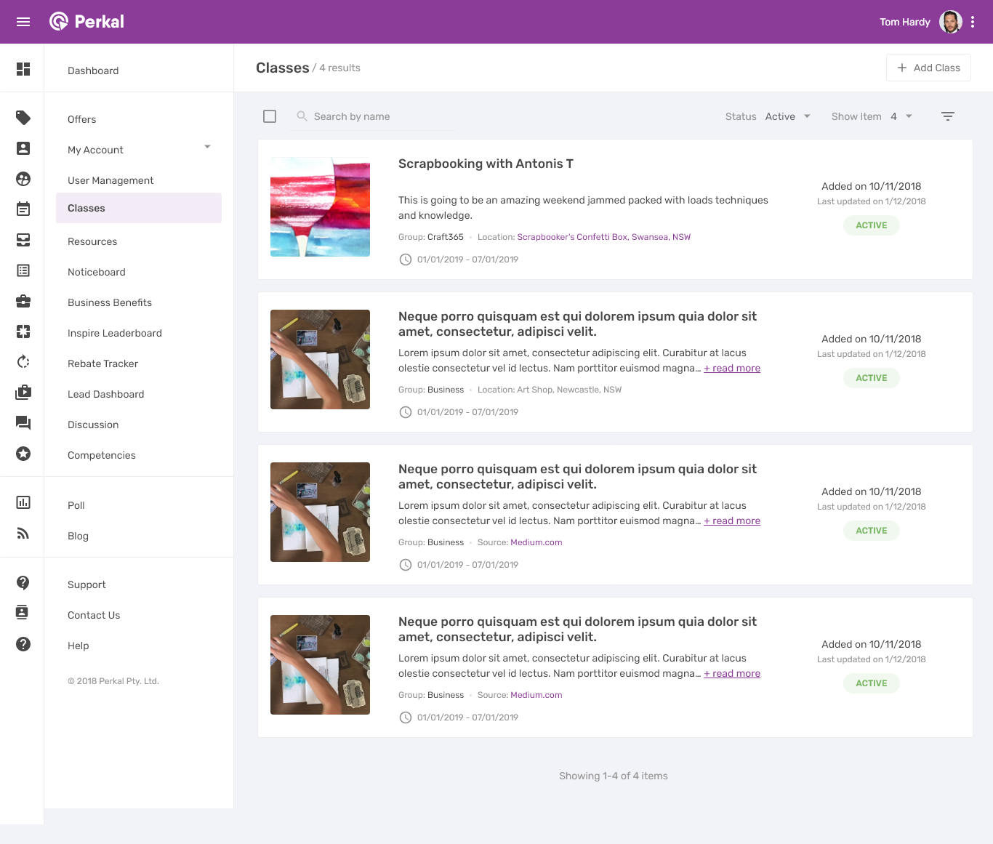

**As a user I want to see the classes that are currently active as a default view.**

* Classes will show in order of soonest first, but this order can be sorted.
* The user will see:
  + Image
  + Title
  + Preview text
  + Groups this is showing to
  + Location
  + Start date and end date
  + Date added
  + Date updated
  + Active status

**As a user I want to add a new class**

* Given a user clicks on ‘Add class’ they will be taken to the add class page.

**As a user I want to filter the classes**

* Given a user clicks on the filter icon, they will see the filter pop up.
* Given a user applies a filter, the results will be filters and the icon will now show as purple to indicate it is activated.

**As a user I want to be taken to the class details**

* Given a user clicks anywhere on class tile from the list, they will be taken to that class.

**Perks - Classes - Add new class**

The purpose of the page is for the supplier or admin to load a class that a user can view and book.

**Screenshot**

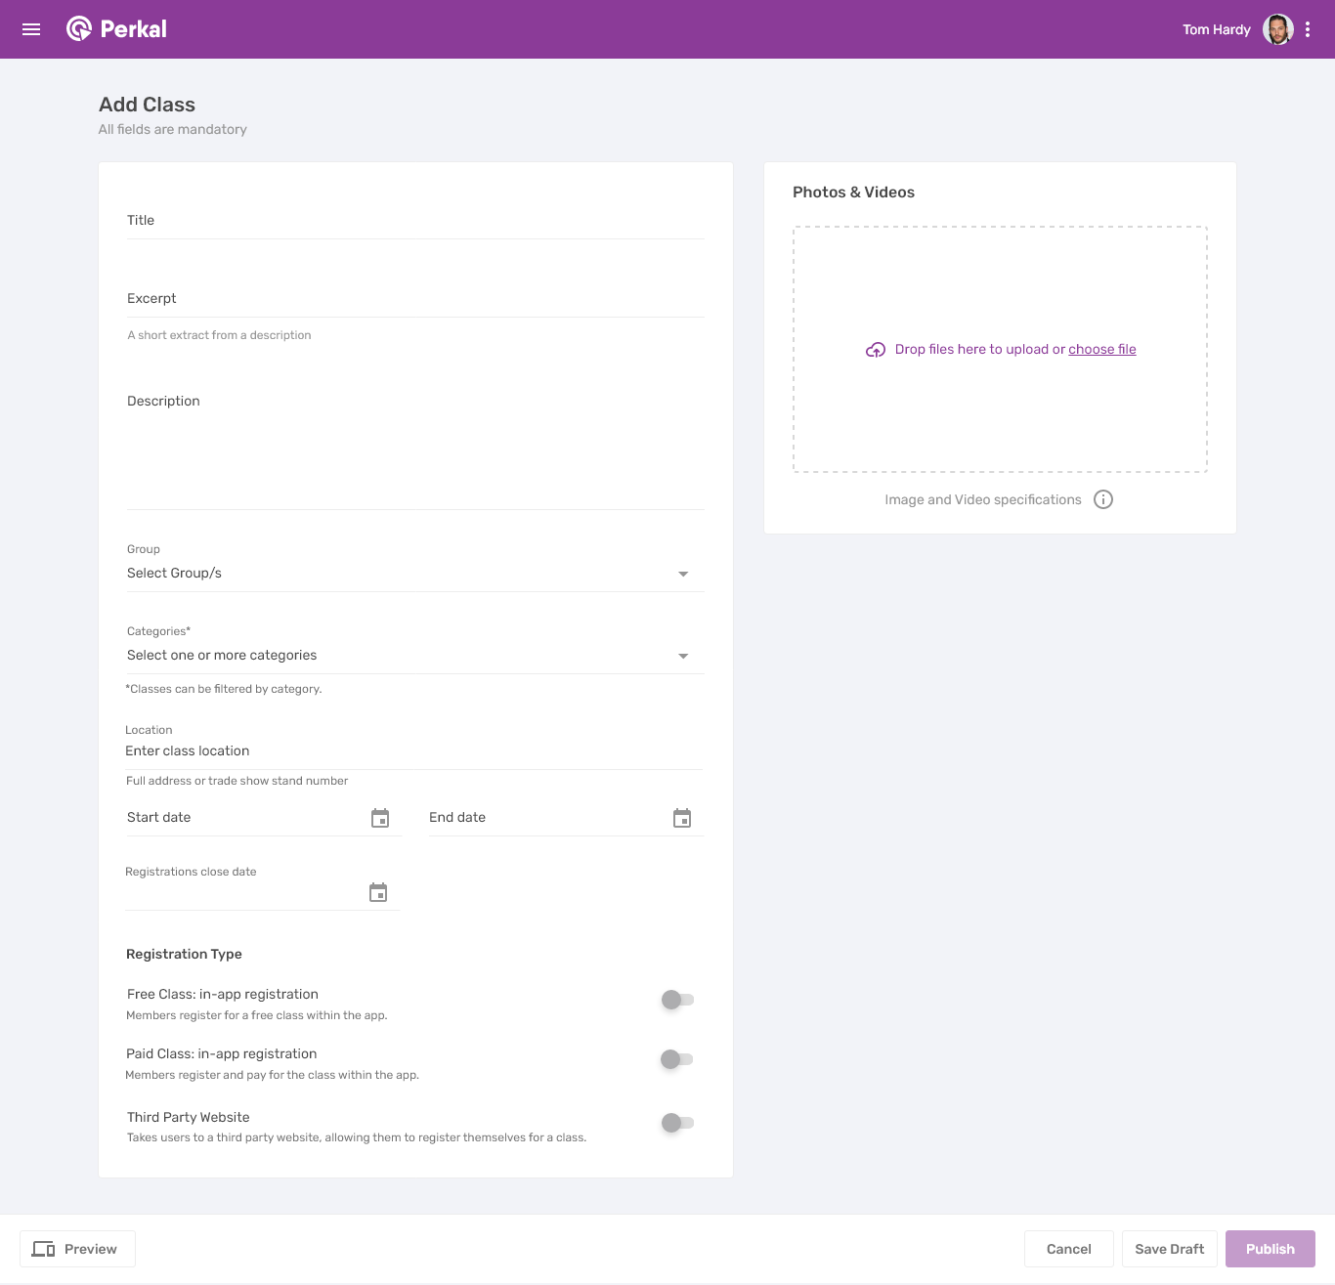

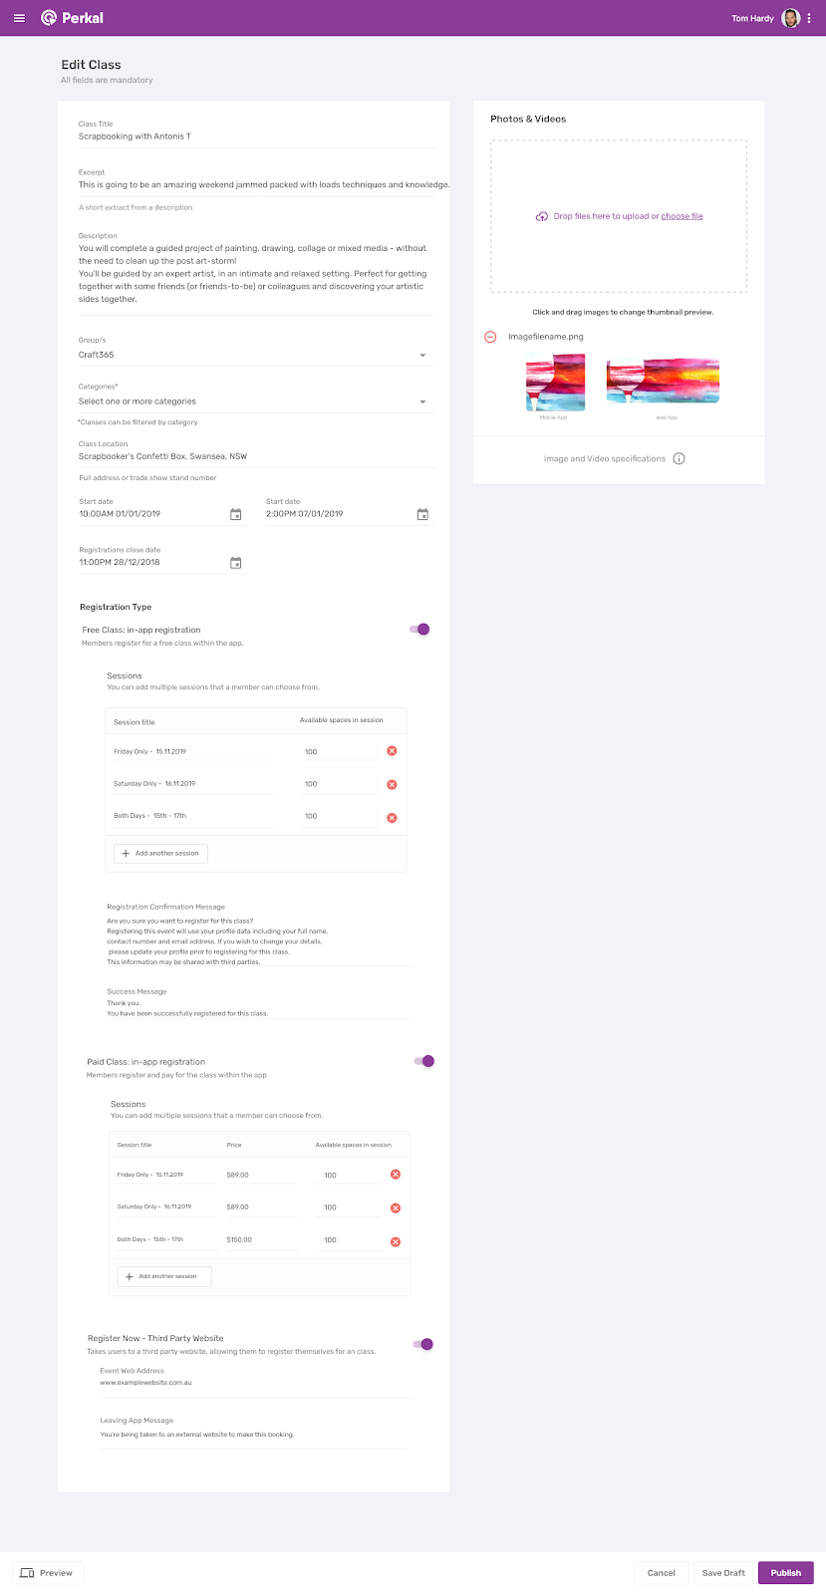

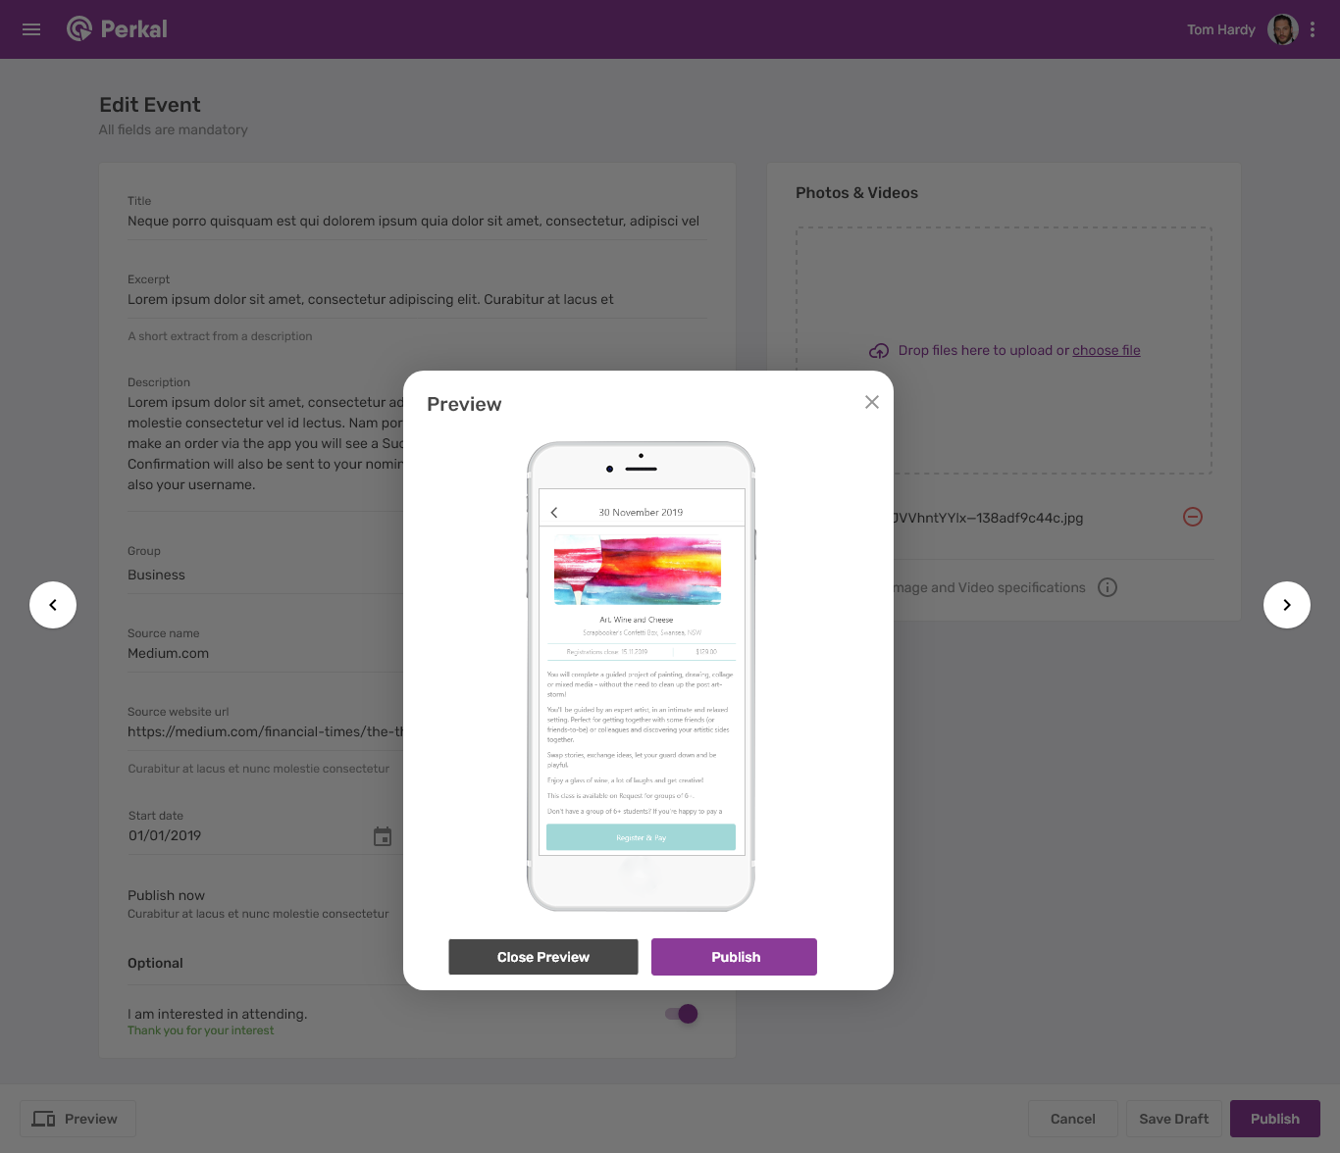

**As a user I want to add a new class by entering the fields:**

* Title
* Expert
* Description
* Groups this will show to (Choosing from list)
* Categories (Choosing from list)
* Location. This could be a street address, or a booth / stand number at a conference.
* Start date of the class
* End date of the class
* Registration close date
* Registration Type. A user can select only ONE of the following:
  + Free Class.
  + Paid Class.
  + Third Party Website.

**As a user I want to select the Registration Type ‘FREE CLASS’**

* Given a user selects ‘FREE CLASS’, they will see the following fields appear in a collapsable menu:
  + Session Title
  + Available spaces
* There will be one line as a default. Given a user clicks ‘Add another session’ they will be able to enter more sessions. They are able to add unlimited sessions.
* Given a user clicks on the ‘x’ this session will be removed.
* Given a user is adding a ‘Free class’ they will need to add a confirmation message that will pop up when the app user is booking. The default text for this message can be updated, but if the user does not edit the text, the message will remain:

Are you sure you want to register for this class?

Registering this event will use your profile data including your full name, contact number and email address. If you wish to change your details, please update your profile prior to registering for this class. This information may be shared with third parties.

* Given a user is adding a ‘Free class’ they will need to add a success  message that will pop up when the app user has booked. The default text for this message can be updated, but if the user does not edit the text, the message will remain:

Thank you.

You have been successfully registered for this class.

**As a user I want to select the Registration Type ‘PAID CLASS’**

* Given a user selects ‘PAID CLASS’, they will see the following fields appear in a collapsable menu:
  + Session Title
  + Price
  + Available spaces
* There will be one line as a default. Given a user clicks ‘Add another session’ they will be able to enter more sessions. They are able to add unlimited sessions.
* Given a user clicks on the ‘x’ this session will be removed.
* In this process, a user will purchase a class through the normal checkout process.

**As a user I want to select the Registration Type ‘Register Now - Third Party Website’**

* Given a user selects ‘**Third Party Website**’, they will see the following fields appear in a collapsable menu:
  + Event Web Address - this is the address that the app user will be taken to to book this class.
  + Leaving App Message.  This is the message that pops up when a user is exiting the app to go to the third party site to book. The default text for this message can be updated, but if the user does not edit the text, the message will remain:

You’re being taken to an external website to make this booking.

**As a user I want to upload photos and / or videos.**

* Given a user clicks or drags and drops to the photo section, they can upload a photo.
* Once the photo is uploaded, they can they drag and place the preview of this image.
* Given a user has loaded a photo and they click the ‘minus’ symbol, this will remove the image. This icon should have a hover pop up that says ‘Remove image’.

**As a user I want to preview the class.**

* Given a user clicks ‘preview’ they should see exactly how this will look on:
  + A phone
  + An ipad
  + In web.
* The user can click ‘next’ to see the next preview.

**As a user I want to publish the class.**

* Given a user clicks ‘Publish’ - the event will go live.

**As a user I want to save the details I have entered and continue later.**

* Given a user clicks ‘Save draft’ they details entered will be saved, and they will be able to continue later.

**As a user I want to cancel**

* Given a user clicks on ‘Cancel’ they will see a pop up that says ‘Are you sure you want to cancel? All details entered will be lost.’
* If a user clicks ‘cancel’ they will be taken back to the events page.

**Perks - Classes - View Class Details**

The purpose of the page is for the supplier or admin to view the details and registered attendees of a class, as well as “Check in” attendees.

**Screenshots**

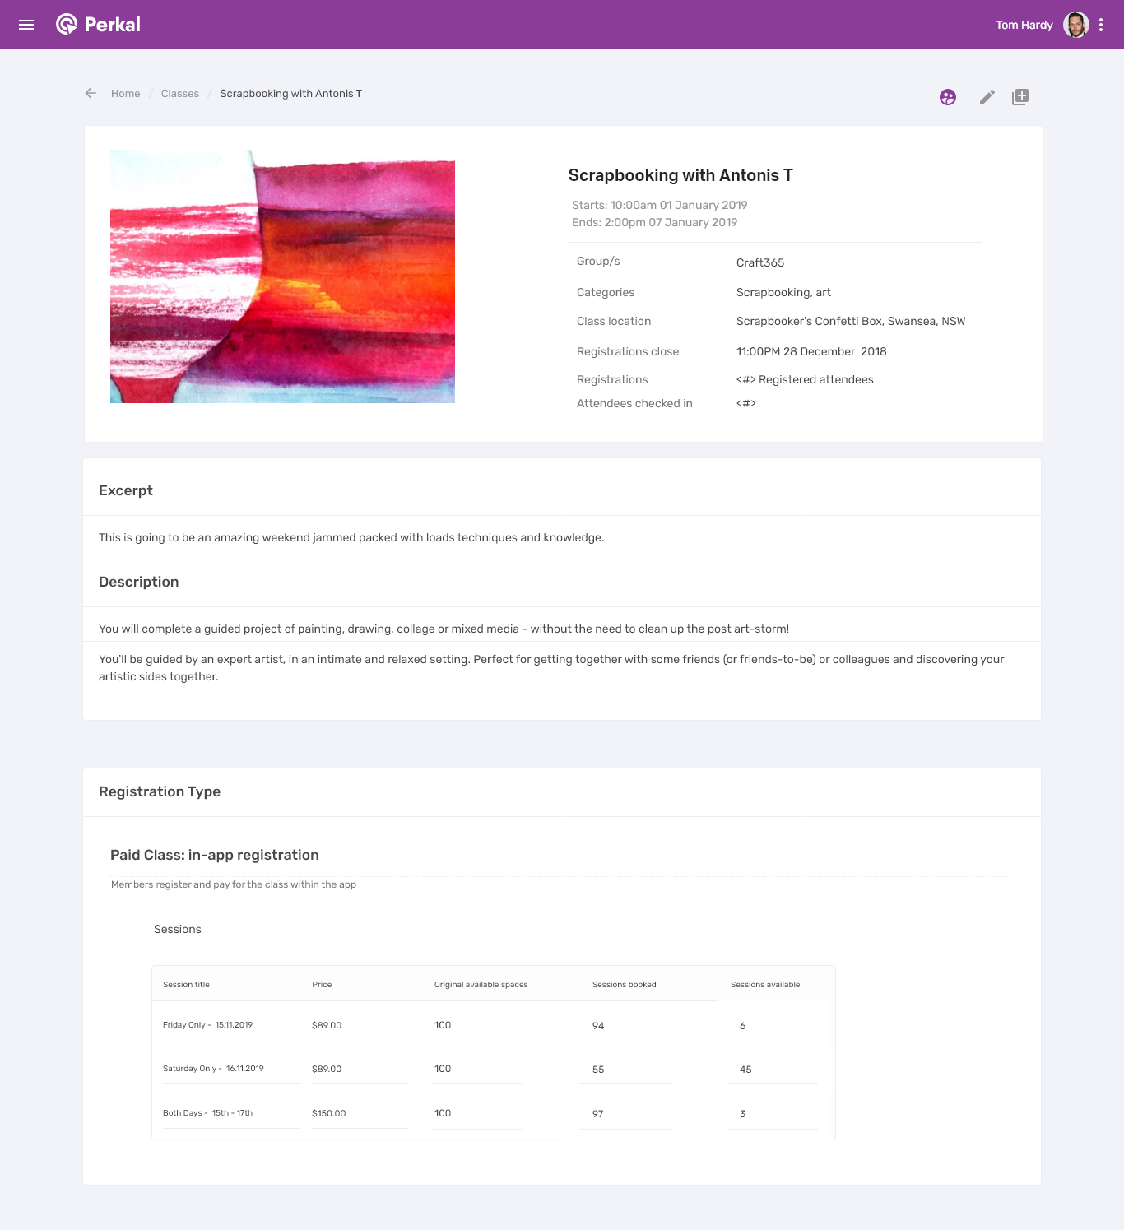

**As a user I want to see the following details of a class**

* Title
* Start time and date
* End time and date
* Groups this will show to (Choosing from list)
* Categories (Choosing from list)
* Location. This could be a street address, or a booth / stand number at a conference.
* Registration close date
* How many registrations there have been
* How many attendees have been checked in.
* Expert
* Description
* Registration Type, including any sessions loaded.

**As a user I want to see the people registered to attend the class.**

* Given user clicks on the people icon in the top right, they will be taken to the attendee list (see this user story below)

**As a user I want to edit the details of this class.**

* Given user clicks on the ‘edit’ icon in the top right, they will be taken to edit the class details.

**As a user I want to duplicate this class.**

* Given user clicks on the ‘duplicate’ icon in the top right, they will see a pop up confirming that they would like to duplicate this class. If they click ‘Duplicate’ they be taken to a duplicate of this class to edit. If they click ‘Cancel’ then the pop up will close.

**Perks - Classes - View Attendee List**

The purpose of the page is for the supplier or admin to view the registered attendees of a class, as well as “Check in” attendees.

**Screenshots**

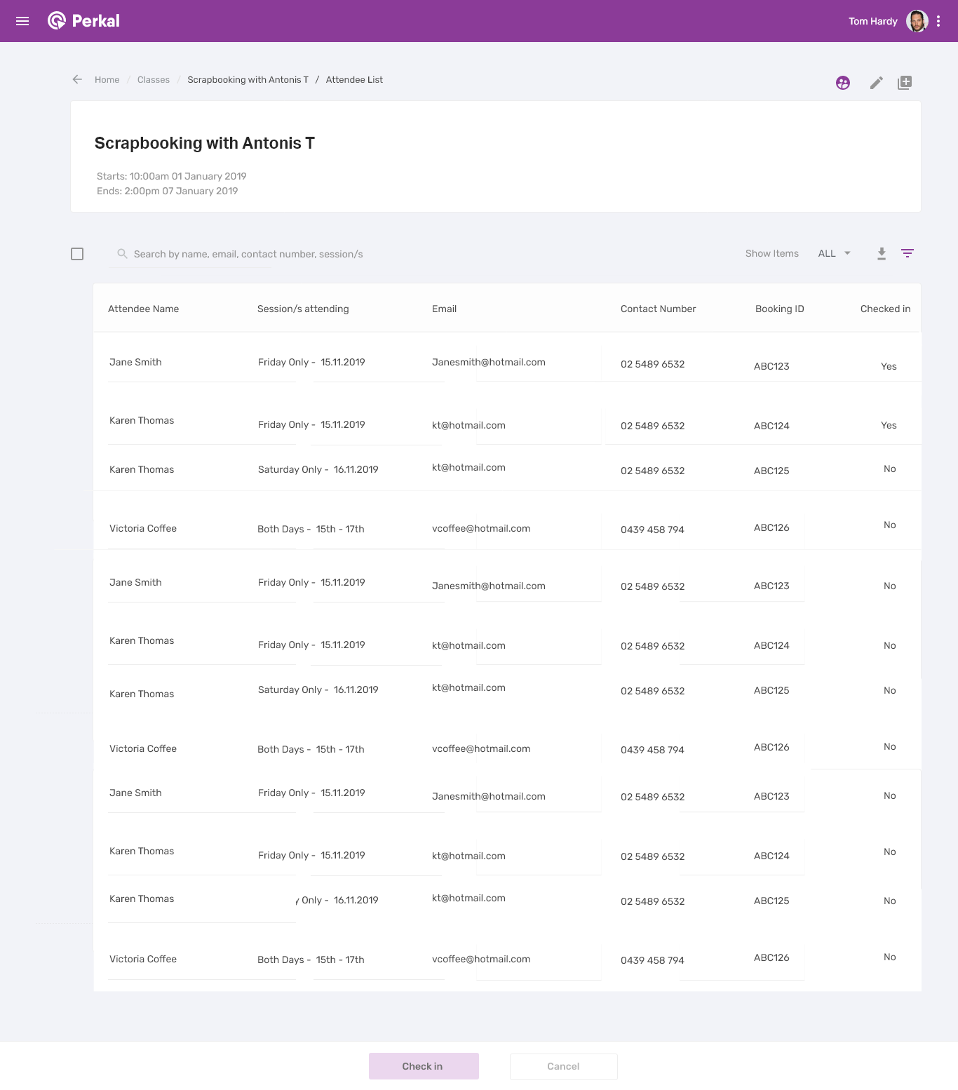

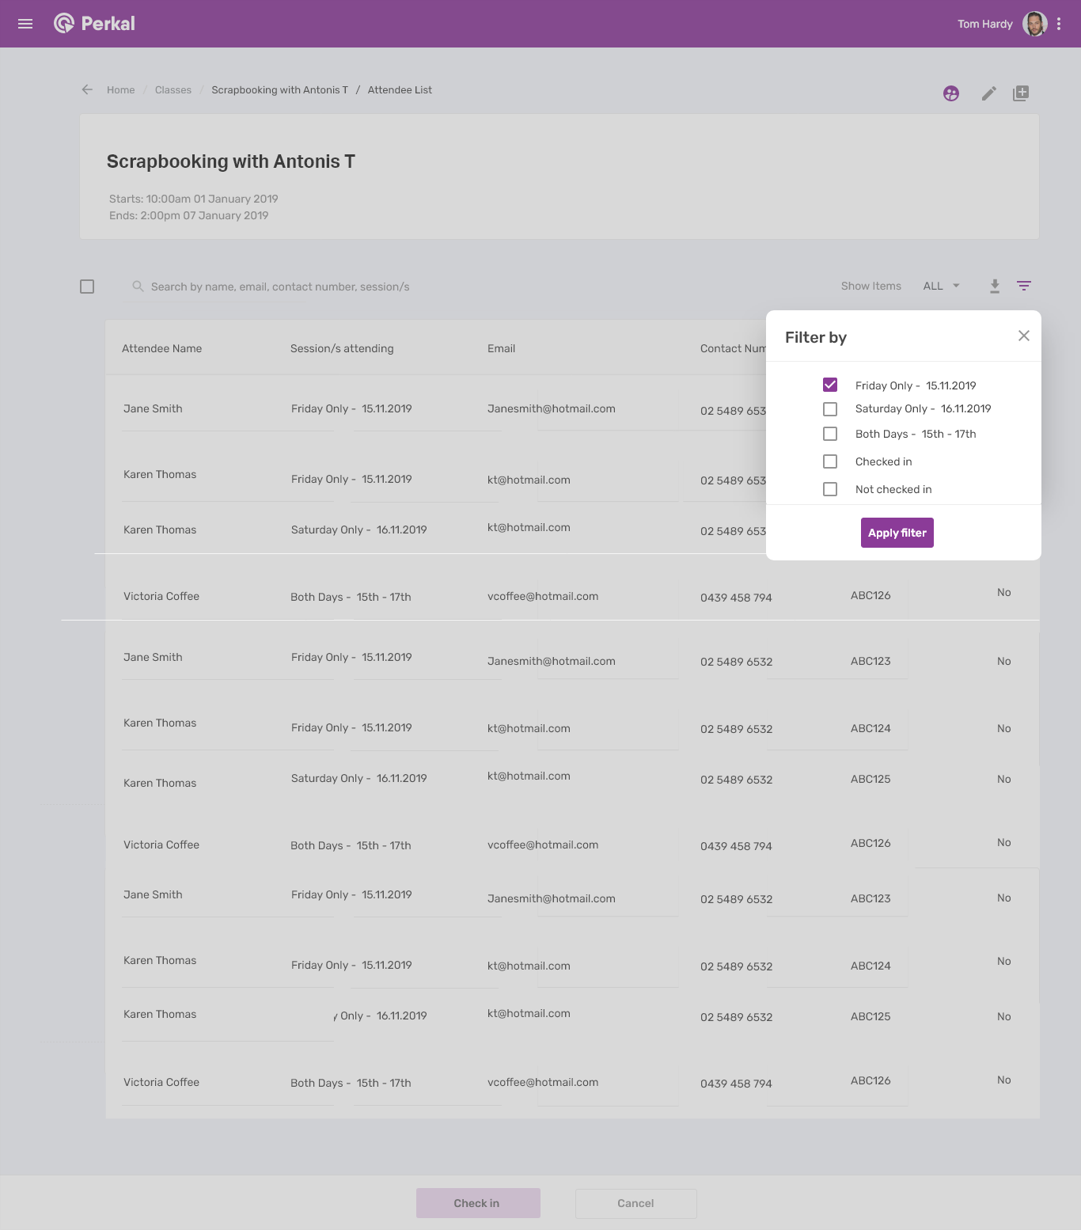

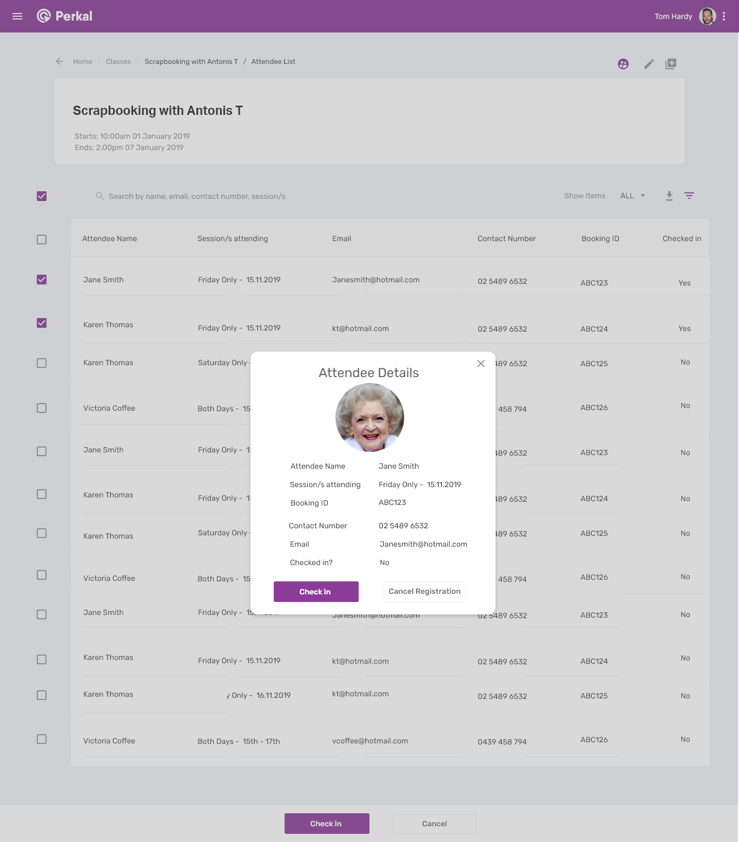

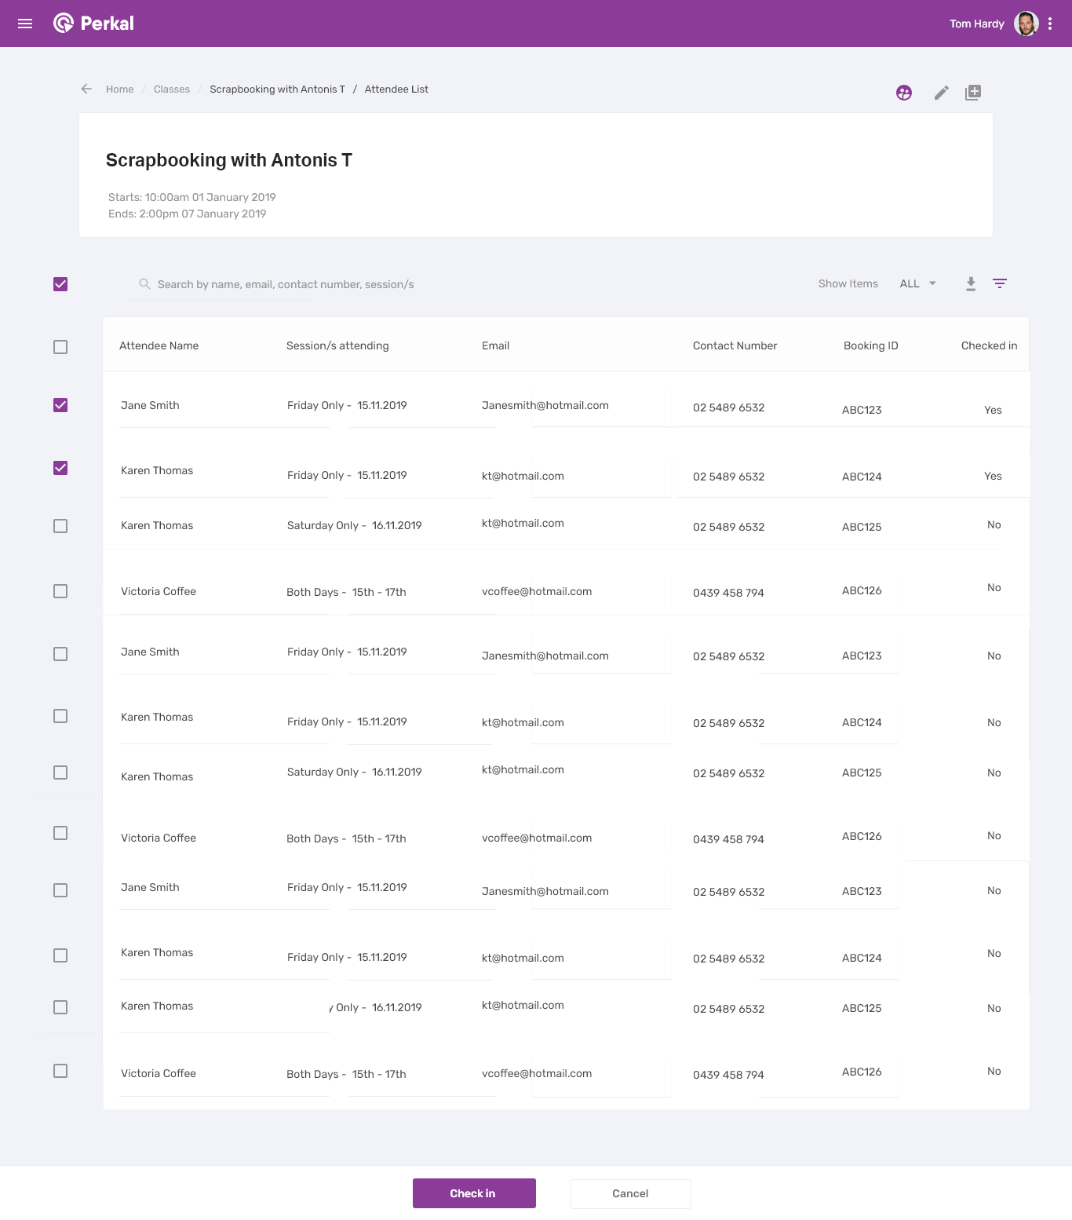

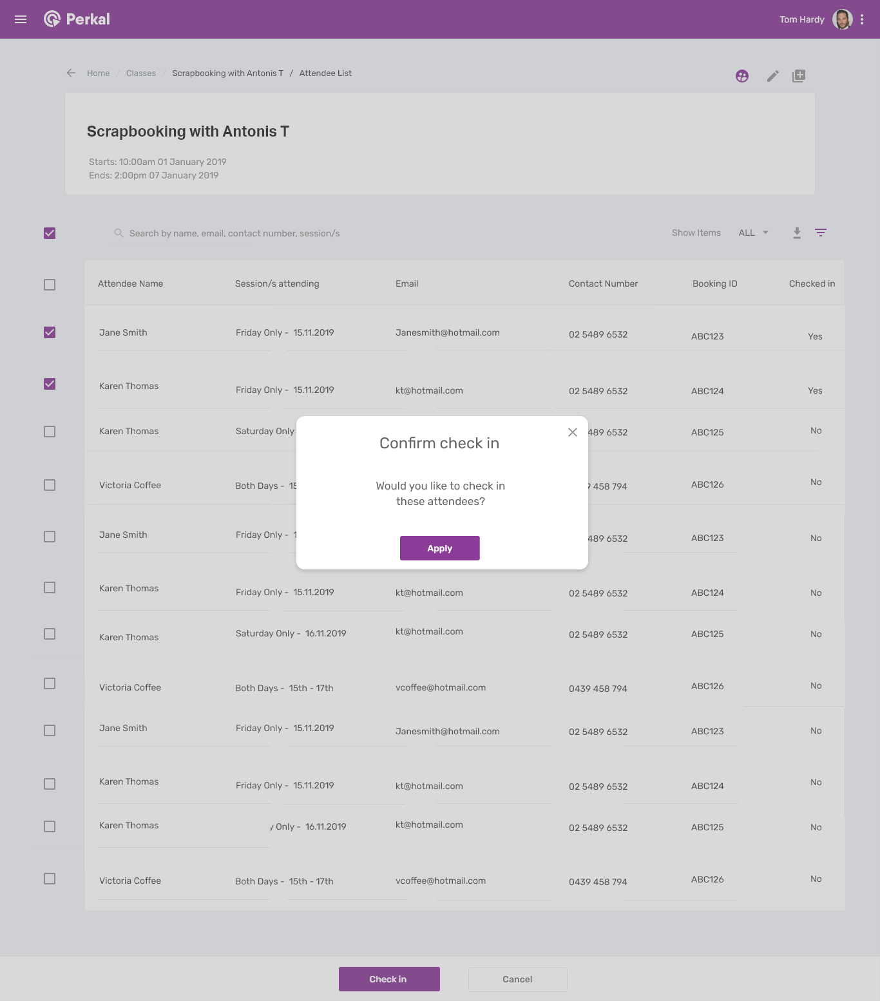

**As a user I want to see the following summary details of a class**

* Title
* Start time and date
* End Date and Time

**As a user I want to see the following details of an attendee**

* First name and surname
* Sessions they’re attending
* Email
* Contact number
* Booking ID (unique identification number assigned when a customer books into a class)
* Checked in status: yes / no.

**As a user I want to be able to search the attendee list.**

* Given a user starts typing in the search bar, the results will immediately start filtering.
* A user can search by name, email, phone number, booking ID, sessions.

**As a user I want to check in attendees.**

* Given a user hovers over the check box to the left of the search bar, they will see a hover over pop up that says ‘Check in attendees’.
* Given a user clicks on the check box, then they will see check boxes next to all users.
* Given a user clicks on the check box next to the headings, then all users will be selected.
* Given a user clicks checks on a box next to a user, then they can click on ‘Check in’ at the bottom to check in the user/s.
* They will see a pop up that says ‘Would you like to check in these attendees?’  They can click ‘Apply’ or ‘Cancel’.  
  Given a user clicks on ‘Cancel’ at the bottom of the page, then all changes will be cancelled.

**As a user I want to see the details of an attendee.**

* Given a user clicks on any detail of an attendee, then an information box will show. This will include all details of the attendee.
* From this box a user can check in a user.
* They can also cancel registration from this list. This will remove the user from the class.

**As a user I want to download / export the attendee list.**

* Given a user clicks on the download button next to the filter icon, they will be able to choose to download the list as XLS, CSV or PDF.

**Mobile Classes Descriptions**

# Perks / Craft365 – Classes

The purpose of the page is for the user to view and register for classes.

Classes can be scheduled by an admin, or from a supplier with admin approval.

Class registration types can include:

* A class with one session that users can purchase through the app.
* A class with multiple sessions that users can select their preference/s and purchase through the app.
* A class with one session that is free.
* A class with multiple sessions that is free.
* A class with a button that takes you to an external, 3rd party website to book and/or pay.

## Related Pages

* Menu
* Class Details
* Home
* My Orders

# Screenshots

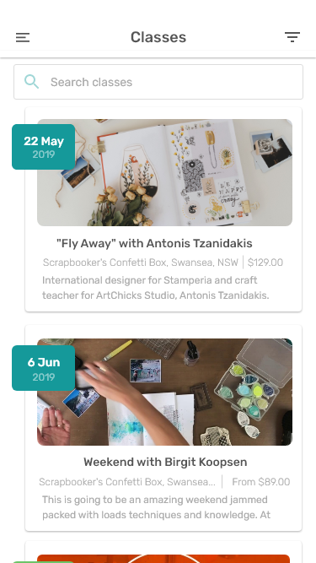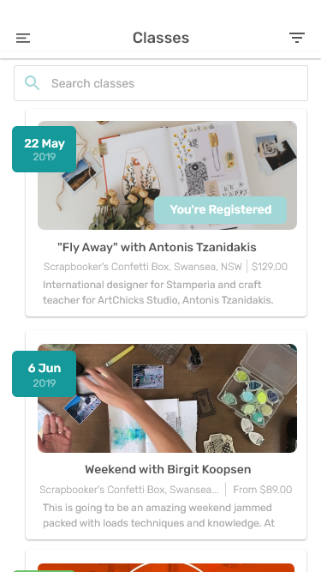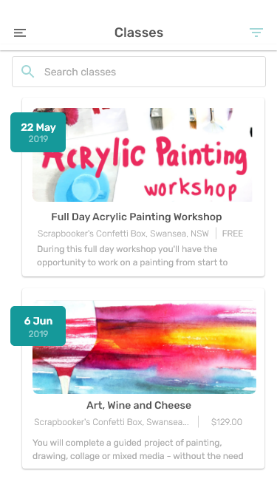

**As a user I want to be able to return to the main menu.**

* Given a user clicks on the menu item in the top left, they will be taken back to the menu.

**As a user I want to see the classes that are currently available**

* Events will show in order of soonest first.
* The user will see:
  + Image
  + Start Date
  + Title
  + Location
  + Cost. If a class is free, this will show as ‘FREE” if a class has one session, then the cost will show as ‘$00.00’ and if the class has multiple sessions, the cost will show the LOWEST cost and show ‘From $00.00’
  + Preview text
  + If a user has already registered for a class, they will see a banner that says ‘You’re Registered’

#### As a user I want to be able to search for classes

* Given a user clicks on the search bar, the keyboard will appear the page heading will change to ‘Search classes’,
* Given a  user starts typing, THEN  the search results will dynamically appear AND classes will continue to update as more text is added to the ‘Search Bar’

**As a user I want to be notified if no offers match my search.**

* Given a user has typed in the search bar AND no items match this search, I will not see any results. I will see:

*Sorry! No results found for  "<Text Entered in Search Bar>"*

*Please check your spelling or modify your search.*

**As a user I want to see the classes available relevant to my search:**

* Given a user has typed in the search bar, they will see summary details of relevant classes:
* The user will see:
  + Image
  + Start Date
  + Title
  + Location
  + Price
  + Preview text

**As a user I want to be taken to the class details**

* Given a user clicks anywhere on class tile from the list, they will be taken to that class.

**As a user I want to filter the classes**

* Given a user clicks on the filter button in the top left, the ‘Filter Classes’ pop up will show.
* Given the admin has set the parameters for this class, a user will be able to filter based on the location listed in the app profile.
* Given a user filters by categories, then only classes linked to those categories will show.
* Given a user applies a filter, the filter icon will change colours to indicate a filter is applied.

### Page Actions

1. Return to Menu by clicking ‘Menu’
2. Search Classes
3. View Class Details’ page
4. Filter Classes

### Page Elements

There are 3 key elements on this page:

1. Top Menu
2. Search bar
3. Class tiles

# Class Details:

**A class with one session that users can purchase through the app.**

The purpose of the page is for the user to view and register for a class with one session that users can purchase through the app.

**Page**

TCB

## Related Pages

* Classes
* Payments Page
* Verification page
* Purchase confirmation page

# Screenshot

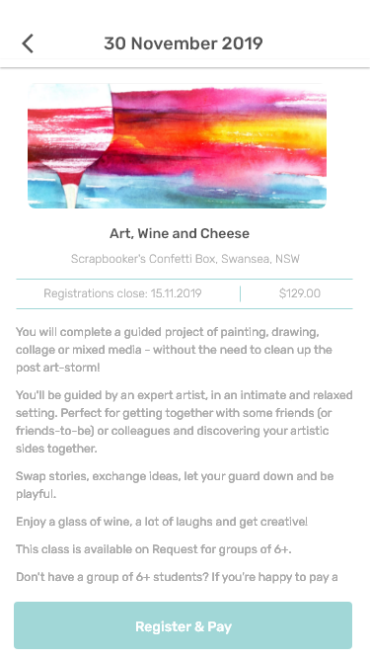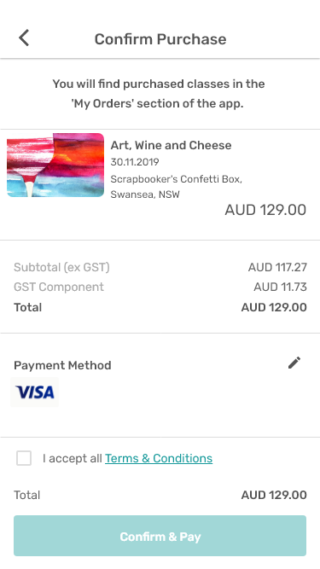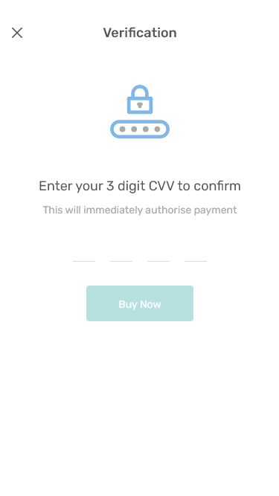

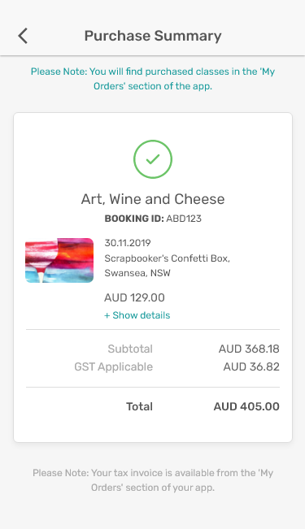

## Stories

### The User Stories

**As a user I want to be able to return to the Classes section**

* Given a user clicks on the ‘back’ icon in the  top left, they will be taken back to the Classes page.

**As a user I want to see the Class date/s**

* A user will be able to see view the class date/s.
* If a class is on one day, it will show the start date.
* If a class starts on one day and finishes on a different date, both the start and end dates will show.

**As a user I want to see the Class image**

* A user will be able to see view the class  image, click to view in full screen and zoom in on full screen image.

**As a user I want to see the Class title**

* The Class title will appear across a maximum of two lines.

**As a user I want to see the Class location**

* The Class location will show under the class tille.

**As a user I want to see the Class cost**

* The Class cost will show under the class title

**As a user I want to read the description as entered by admin**

* Given a user scrolls down, they will see the class description

**As a user I want to register and pay for this class.**

* Given a user clicks on ‘Register and Pay’ they will be taken to the payment confirmation page.

**As a user I want to pay for this class.**

* Given a user is on the ‘Confirm Purchase’ page and they agree to the terms and conditions and click ‘Confirm & Pay’ they will be taken to enter their CCV.
* Once a user has entered their CCV and they payment is successful, they will see the ‘Purchase Confirmation’ page.

**As a user I want to see the following details on the ‘Purchase Confirmation’ Page:**

* The class name
* Their unique booking ID to identify them when the check into the class.
* The date of the class
* The location of the class
* The cost of the class including the breakdown of costs**.**
* The supplier of the class

### Page Actions

1. Return to Classes by clicking ‘back’ icon
2. Click to see image in full screen
3. Scroll down to see more details
4. Click call to register and pay

### Page Elements

There are 6 key elements on this page:

1. Top Menu
2. Class title
3. Class location
4. Image
5. Details
6. Call to action button

# Class Details -

**A class with multiple sessions that users can purchase through the app.**

The purpose of the page is for the user to view and register for a class with multiple sessions that users can purchase through the app.

**Page**

TCB

## Related Pages

* Classes
* Payments Page
* Verification page
* Purchase confirmation page

# Screenshots

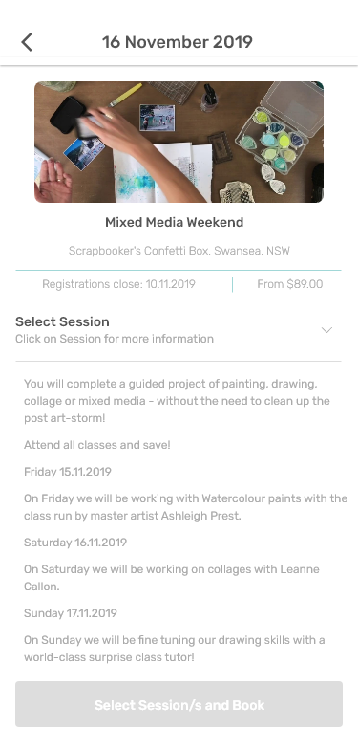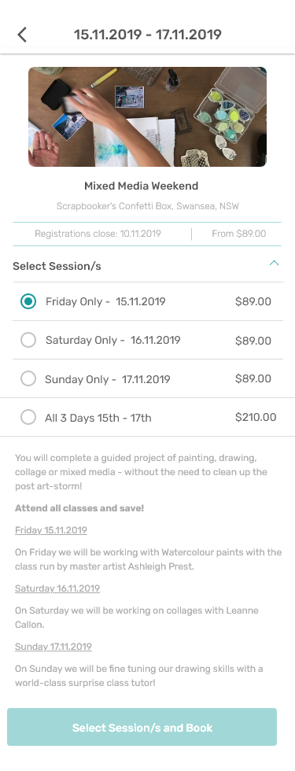

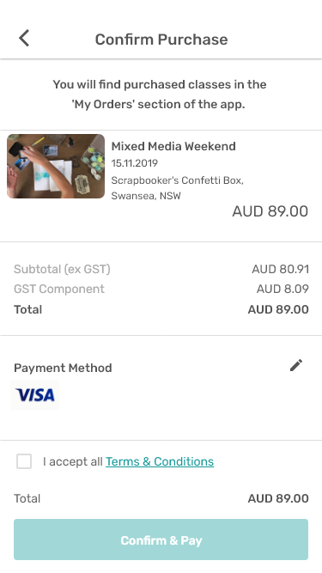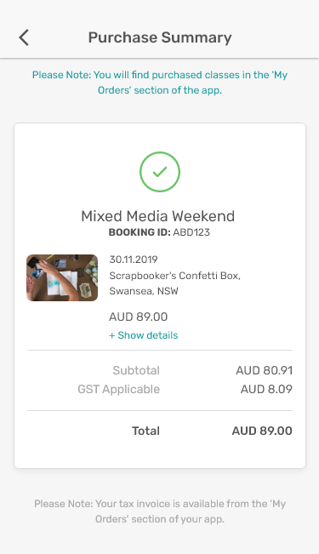

## Stories

### The User Stories

**As a user I want to be able to return to the Classes section**

* Given a user clicks on the ‘back’ icon in the  top left, they will be taken back to the Classes page.

**As a user I want to see the Class date/s**

* A user will be able to see view the class date/s.
* If a class is on one day, it will show the start date.
* If a class starts on one day and finishes on a different date, both the start and end dates will show.

**As a user I want to see the Class image**

* A user will be able to see view the class  image, click to view in full screen and zoom in on full screen image.

**As a user I want to see the Class title**

* The Class title will appear across a maximum of two lines.

**As a user I want to see the Class location**

* The Class location will show under the class tille.

**As a user I want to see the Class cost**

* As a class has multiple sessions, the cost will show the LOWEST cost and show ‘From $00.00’

**As a user I want to read the description as entered by admin**

* Given a user scrolls down, they will see the class description

**As a user I want to see what sessions are available.**

* Given a user clicks on the ‘sessions’ section, the menu will collapse and they will be able to see and select their preferred session/s.
* Once the sessions menu is collapsed, the drop down arrow will change colour.

**As a user I want to select my session/s and register and pay for this class.**

* Once a user has selected one of more sessions, they ‘Register and Pay’ button will be clickable and change colour. Before any sessions have been selected, this button will not be able to be clicked.
* Given a user selections one or more sessions and then clicks on ‘Register and Pay’ they will be taken to

the payment confirmation page.

**As a user I want to pay for this class.**

* Given a user is on the ‘Confirm Purchase’ page and they agree to the terms and conditions and click ‘Confirm & Pay’ they will be taken to enter their CCV.
* Once a user has entered their CCV and they payment is successful, they will see the ‘Purchase Confirmation’ page.

**As a user I want to see the following details on the ‘Purchase Confirmation’ Page:**

* The class name
* Their unique booking ID to identify them when the check into the class.
* The date of the class
* The location of the class
* The cost of the class including the breakdown of costs**.**
* The supplier of the class

### Page Actions

1. Return to Classes by clicking ‘back’ icon
2. Click to see image in full screen
3. Scroll down to see more details
4. Click call to register and pay

### Page Elements

There are 6 key elements on this page:

1. Top Menu
2. Class title
3. Class location
4. Image
5. Details
6. Call to action button

# Class Details:

**The purpose of the page is for the user to view and action a class with one session that is free.**

**Page**

TCB

## Related Pages

* Classes

# Screenshot

## 

## Stories

### The User Stories

**As a user I want to be able to return to the Classes section**

* Given a user clicks on the ‘back’ icon in the  top left, they will be taken back to the Classes page.

**As a user I want to see the Class date/s**

* A user will be able to see view the class date/s.,

**As a user I want to see the Class image**

* A user will be able to see view the class  image, click to view in full screen and zoom in on full screen image.

**As a user I want to see the Class title**

* The Class  title will appear across a maximum of two lines.

**As a user I want to see the Class location**

* The Class location will show under the class total.

**As a user I want to see that this class is free**

* ‘FREE’ will show next to the class location.

**As a user I want to read the description as entered by admin**

* Given a user scrolls down, they will see the class description

**As a user I want to register for this class.**

* Given a user clicks on ‘Register Now’’ they will be taken to the payment confirmation page.

**As the admin, I want users to register in the app:**

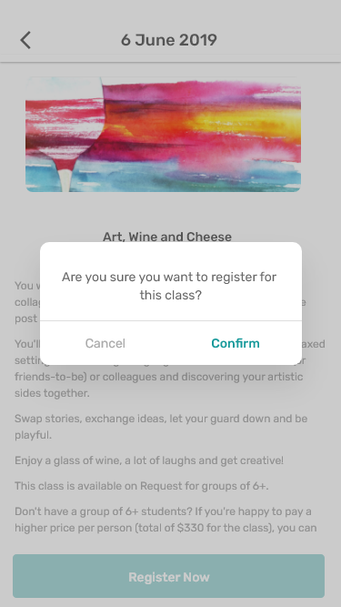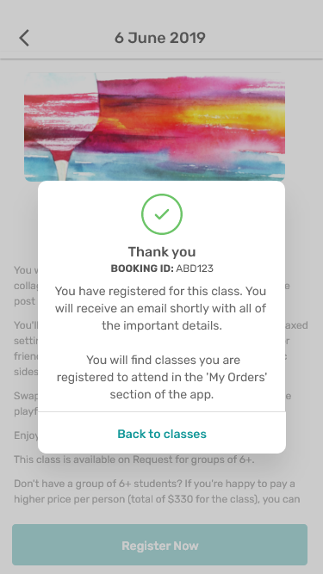

* Given a user clicks on ‘Cancel’ they will be taken back to the Class Details page.
* Given a user clicks on ‘Confirm’ they will be registered and see the ‘Thank You’ confirmation pop up.
* Given a user clicks on ‘Back to classes’ this pop up will close and they will be shown the ‘Class Details’ page.

### Page Actions

1. Return to Classes by clicking ‘back’ icon
2. Click to see image in full screen
3. Scroll down to see more details
4. Click call to register

### Page Elements

There are 6 key elements on this page:

1. Top Menu
2. Class title
3. Class location
4. Image
5. Details
6. Call to action button

# Class Details

**The purpose of the page is for the user to view and action a class with multiple sessions that is free.**

**Page**

TCB

## Related Pages

* Classes

# Screenshot

## 

## Stories

### The User Stories

**As a user I want to be able to return to the Classes section**

* Given a user clicks on the ‘back’ icon in the  top left, they will be taken back to the Classes page.

**As a user I want to see the Class date/s**

* A user will be able to see view the class date/s.,

**As a user I want to see the Class image**

* A user will be able to see view the class  image, click to view in full screen and zoom in on full screen image.

**As a user I want to see the Class title**

* The Class  title will appear across a maximum of two lines.

**As a user I want to see the Class location**

* The Class location will show under the class total.

**As a user I want to see that this class is free**

* ‘FREE’ will show next to the class location.

**As a user I want to read the description as entered by admin**

* Given a user scrolls down, they will see the class description

**As a user I want to see what sessions are available.**

* Given a user clicks on the ‘sessions’ section, the menu will collapse and they will be able to see and select their preferred session/s.
* Once the sessions menu is collapsed, the drop down arrow will change colour.

**As a user I want to select my session/s and register for this class.**

* Once a user has selected one of more sessions, they ‘Register Now’ button will be clickable and change colour. Before any sessions have been selected, this button will not be able to be clicked.
* Given a user selections one or more sessions and then clicks on ‘Register Now’ they will see the confirmation pop up. .

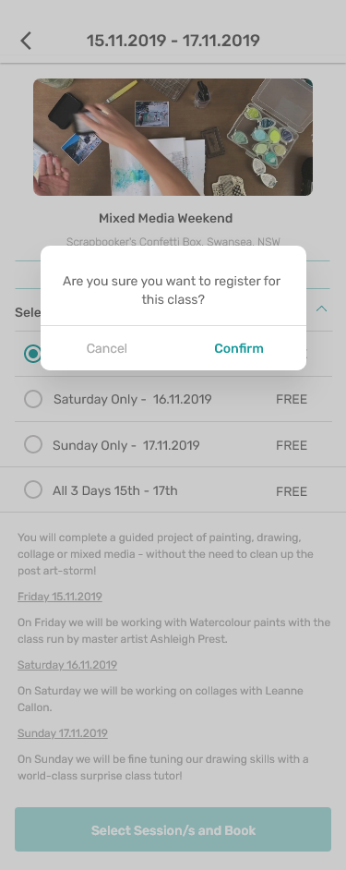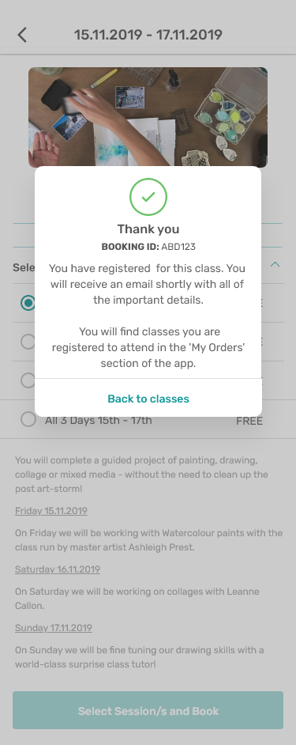

* Given a user clicks on ‘Cancel’ they will be taken back to the Class Details page.
* Given a user clicks on ‘Confirm’ they will be registered and see the ‘Thank You’ confirmation pop up.
* Given a user clicks on ‘Back to classes’ this pop up will close and they will be shown the ‘Class Details’ page.

### Page Actions

1. Return to Classes by clicking ‘back’ icon
2. Click to see image in full screen
3. Scroll down to see more details
4. Click call to register

### Page Elements

There are 6 key elements on this page:

1. Top Menu
2. Class title
3. Class location
4. Image
5. Details
6. Call to action button

# Class Details

The purpose of the page is for the user to view and action a class with a button that takes you to an external, 3rd party website to book and/or pay.

**Page**

TCB

## Related Pages

* Classes

# Screenshot

## 

## Stories

### The User Stories

**As a user I want to be able to return to the Classes section**

* Given a user clicks on the ‘back’ icon in the  top left, they will be taken back to the Classes page.

**As a user I want to see the Class date/s**

* A user will be able to see view the class date/s.,

**As a user I want to see the Class image**

* A user will be able to see view the class  image, click to view in full screen and zoom in on full screen image.

**As a user I want to see the Class title**

* The Class  title will appear across a maximum of two lines.

**As a user I want to see the Class location**

* The Class location will show under the class total.

**As a user I want to see that this class is free or the class cost.**

* The class cost as entered by the admin will show in this section.

**As a user I want to read the description as entered by admin**

* Given a user scrolls down, they will see the class description

**As the admin, I want users to be taken to an external site :**

* Given a user clicks on ‘Register Now’ they will see a pop up that says:
  + You’re  being taken to an external website to make this booking.
  + Given a user clicks on ‘cancel’ the pop up will close and they will see the Class Details page again.
  + Given a user clicks on Let’s go’ they will be taken to the 3rd party website to make the booking.

### Page Actions

1. Return to Classes by clicking ‘back’ icon
2. Click to see image in full screen
3. Scroll down to see more details
4. Click call to register

### Page Elements

There are 6 key elements on this page:

1. Top Menu
2. Class title
3. Class location
4. Image
5. Details
6. Call to action button

# My Orders - Classes

The purpose of the page is for the user to view their confirmed and purchased classes.